Chapter 6 Even Numbers Homework

6.2. 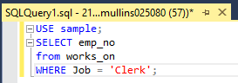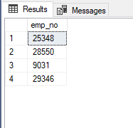

6.4. 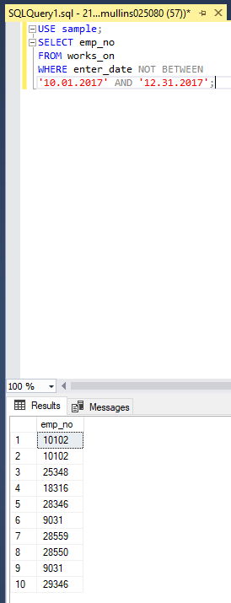

6.6. 

6.8. 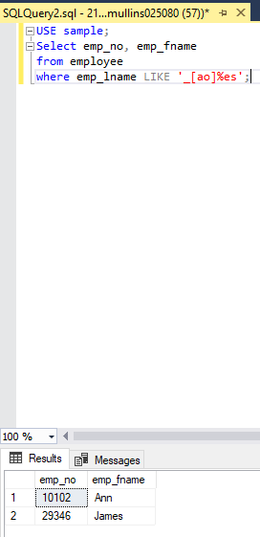

6.10. 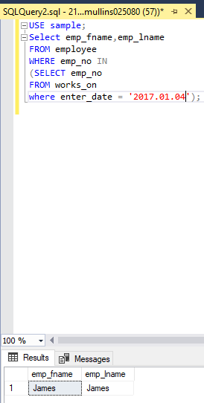

6.12. there is no difference.

6.14. It displays all the non-NULL answers of the query

6.16. 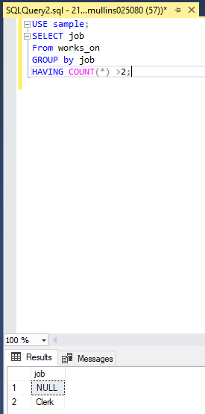

6.19. Temporary tables are used to store the previous results if a complicated query is used.

6.20. Local temporary table are not saved at the end of the session, while global temporary tables are saved.